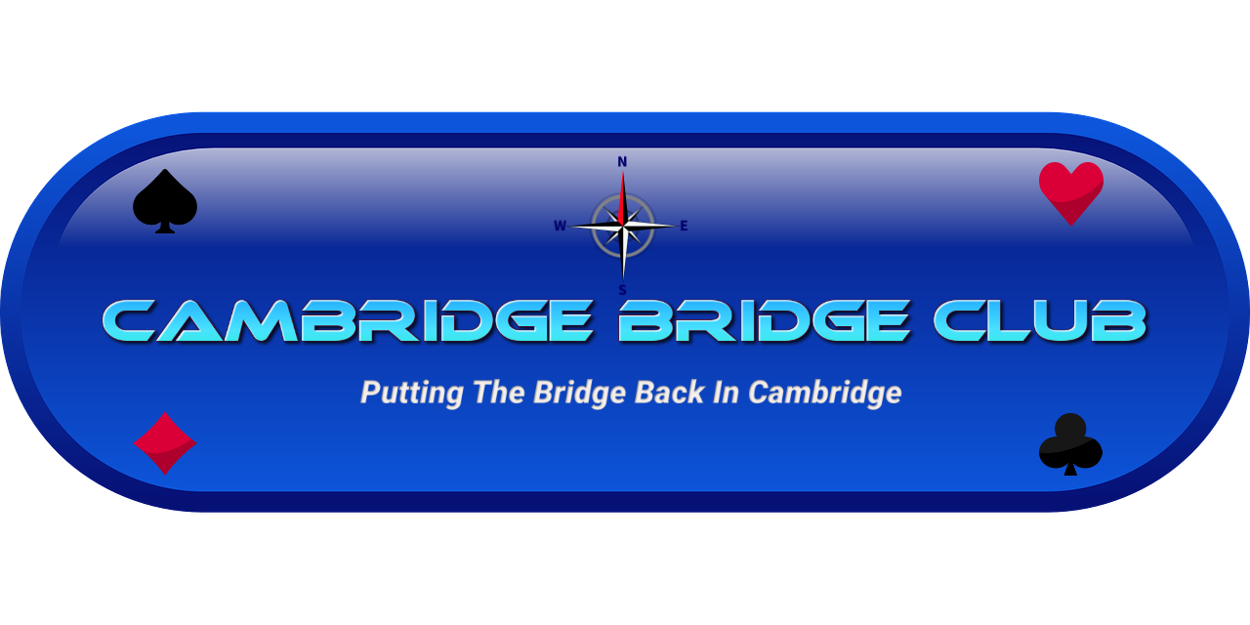
Lessons Registration Form 2024

Name:
Mobile or Best Contact #:
Email:
Are you interested in:  Daytime Lessons  Evening Lessions | Yes / No  Yes / No  (please indicate preferred session)
Have you played bridge before? | Yes / No
How did you hear about our lessons?
What card games have you played?
Who do you know at Cambridge Bridge Club?

To email your registration form, please click here

